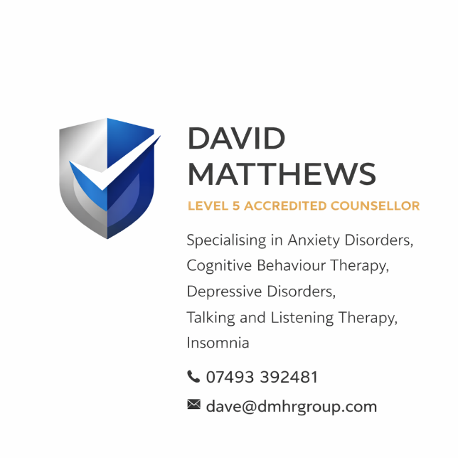

DAVID MATTHEWS GROUP

COUNSELLING SERVICE

SAFEGUARDING POLICY
Policy Title: Safeguarding Adults and Children Policy
Effective Date: 23 March 2026
Review Date: March 2027
Policy Owner: David Matthews, Director

1. POLICY STATEMENT
David Matthews Group – Counselling Service is fully committed to safeguarding and promoting the welfare of all individuals who access our services. This includes adults, young people, and children who may be vulnerable due to mental health conditions, life circumstances, or personal experiences.
We provide counselling and therapeutic support in the following areas:
- Anxiety Disorders
- Bereavement Counselling
- Depressive Disorders
- Insomnia
- Talking and Listening Therapy
We recognise that individuals accessing these services may present with increased vulnerability. Safeguarding is therefore embedded at the core of our practice, ensuring that all service users are protected from harm, abuse, neglect, and exploitation.
We operate in line with UK safeguarding legislation and guidance, including:
- The Care Act 2014
- The Children Act 1989 & 2004
- Working Together to Safeguard Children (2018)
- The Mental Capacity Act 2005
- The Safeguarding Vulnerable Groups Act 2006

2. PURPOSE OF THIS POLICY
This policy sets out:
- Our commitment to safeguarding
- The responsibilities of the organisation and practitioners
- How concerns are identified and managed
- How disclosures are handled
- Reporting procedures and escalation processes

3. SCOPE
This policy applies to:
- David Matthews (Director and Lead Counsellor)
- Any associates, contractors, or practitioners working under the service
- All service users, including adults, children, and young people

4. DEFINITIONS
Safeguarding means protecting a person’s right to live in safety, free from abuse and neglect.
Abuse may include:
- Physical abuse
- Emotional/psychological abuse
- Sexual abuse
- Financial or material abuse
- Neglect or acts of omission
- Discriminatory abuse
- Domestic abuse
- Self-neglect

5. SAFEGUARDING PRINCIPLES
We are guided by the following principles:
- Empowerment: Supporting individuals to make informed decisions
- Prevention: Acting early to reduce risks
- Proportionality: Responding appropriately to risk levels
- Protection: Supporting those most in need
- Partnership: Working with relevant agencies
- Accountability: Ensuring clear roles and responsibilities

6. RESPONSIBILITIES
David Matthews (Director & Safeguarding Lead) is responsible for:
- Acting as the Designated Safeguarding Lead (DSL)
- Ensuring all safeguarding concerns are handled appropriately
- Making referrals to external agencies where required
- Maintaining accurate and confidential records
- Ensuring compliance with legal and ethical standards
All practitioners must:
- Be alert to signs of abuse or neglect
- Act immediately on concerns
- Maintain professional boundaries
- Follow reporting procedures without delay

7. RECOGNISING SAFEGUARDING CONCERNS
Indicators may include (but are not limited to):
- Disclosure of abuse
- Signs of self-harm or suicidal ideation
- Sudden changes in behaviour or presentation
- Signs of neglect or deterioration in wellbeing
- Fearful, withdrawn, or distressed presentation
- Reports of domestic violence or coercion

8. RESPONDING TO DISCLOSURES
If a client discloses abuse or risk:
- Remain calm and listen without judgment
- Do not promise confidentiality
- Reassure the individual they have done the right thing
- Record the disclosure accurately and factually
- Explain next steps clearly

9. CONFIDENTIALITY AND INFORMATION SHARING
Confidentiality is a core part of counselling practice. However, it may be breached where:
- There is a risk of serious harm to the individual or others
- A child or vulnerable adult is at risk
- There is a legal obligation to disclose
Where possible, consent will be sought before sharing information unless doing so would increase risk.

10. REPORTING PROCEDURE
Where a safeguarding concern arises:
- Record the concern immediately
- Assess level of risk
- Where necessary, make a referral to:
  - Local Authority Safeguarding Team
  - Social Services
  - Police (if immediate danger)
- Maintain clear and accurate records
- Follow up appropriately
Emergency situations:
👉 Contact 999 immediately

11. WORKING WITH OTHER AGENCIES
David Matthews Group will work collaboratively with:
- Local Authorities
- Social Services
- NHS Services
- Police
- Other safeguarding partners

12. SAFER WORKING PRACTICES
We ensure:
- Clear professional boundaries at all times
- No dual relationships with clients
- Appropriate communication channels
- Secure record-keeping systems
- Risk assessments where required

13. RECORD KEEPING
All safeguarding concerns will be:
- Recorded promptly
- Stored securely in line with GDPR
- Accurate, factual, and dated

14. TRAINING AND COMPETENCE
David Matthews will:
- Maintain up-to-date safeguarding training
- Engage in continuous professional development
- Ensure knowledge of current legislation and guidance

15. REVIEW
This policy will be reviewed annually or sooner if:
- Legislation changes
- There is a safeguarding incident
- Best practice guidance is updated

16. CONTACT DETAILS
Designated Safeguarding Lead:
David Matthews
📞 07493 392481
📧 dave@dmhrgroup.com

17. POLICY APPROVAL
Signed:
David Matthews
Director – David Matthews Group
Date: 23 March 2026

