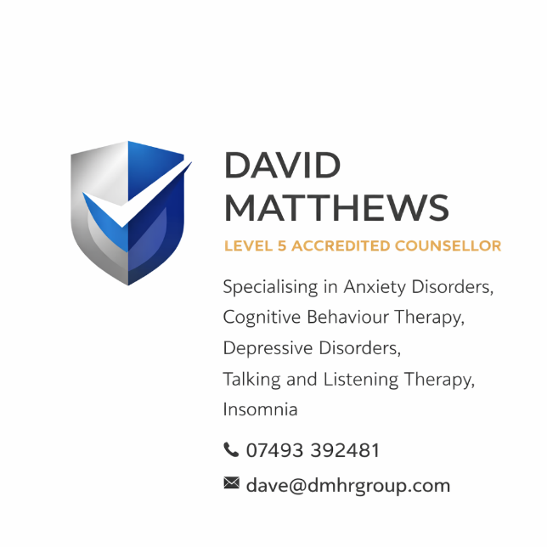

DAVID MATTHEWS GROUP

COUNSELLING SERVICE

EQUALITY, DIVERSITY & INCLUSION (EDI) POLICY
Policy Title: Equality, Diversity & Inclusion Policy
Effective Date: 23 March 2026
Review Date: March 2027
Policy Owner: David Matthews, Director

1. POLICY STATEMENT
David Matthews Group – Counselling Service is fully committed to promoting equality, valuing diversity, and fostering an inclusive environment for all clients, associates, and stakeholders.
We believe that everyone has the right to access safe, respectful, and non-discriminatory counselling services, regardless of their background, identity, or personal circumstances.
Our services—covering anxiety disorders, bereavement, depressive disorders, insomnia, and talking and listening therapy—are delivered in a way that respects and celebrates individual differences, ensuring fair and equitable treatment for all.

2. PURPOSE
This policy outlines our commitment to:
- Eliminating unlawful discrimination
- Promoting equality of opportunity
- Creating an inclusive and respectful service environment
- Ensuring services are accessible to all individuals

3. LEGAL FRAMEWORK
This policy is aligned with the Equality Act 2010, which protects individuals from discrimination based on the following protected characteristics:
- Age
- Disability
- Gender reassignment
- Marriage and civil partnership
- Pregnancy and maternity
- Race (including colour, nationality, ethnic origin)
- Religion or belief
- Sex
- Sexual orientation

4. SCOPE
This policy applies to:
- All clients accessing counselling services
- The Director and any associates or practitioners
- All interactions, communications, and service delivery

5. OUR COMMITMENT
We are committed to:
- Treating all individuals with dignity, respect, and fairness
- Providing services that are free from discrimination, harassment, or victimisation
- Ensuring equal access to counselling services
- Making reasonable adjustments for individuals with disabilities or additional needs
- Challenging discrimination wherever it arises

6. TYPES OF DISCRIMINATION
We recognise and prohibit:
- Direct discrimination – treating someone less favourably
- Indirect discrimination – policies that disadvantage certain groups
- Harassment – unwanted behaviour that violates dignity
- Victimisation – unfair treatment due to raising a concern

7. INCLUSIVE PRACTICE IN COUNSELLING
David Matthews Group will:
- Deliver culturally sensitive and person-centred counselling
- Respect individual identities, beliefs, and lived experiences
- Use inclusive language at all times
- Adapt approaches where necessary to meet individual needs
- Ensure a safe and non-judgemental environment

8. ACCESSIBILITY & REASONABLE ADJUSTMENTS
We will take reasonable steps to ensure accessibility, including:
- Flexible appointment arrangements
- Adjusted communication methods where possible
- Consideration of physical, sensory, or cognitive needs

9. RESPONSIBILITIES
David Matthews (Director) is responsible for:
- Ensuring compliance with this policy
- Promoting inclusive practice
- Addressing any concerns or complaints
All practitioners must:
- Act in accordance with this policy
- Treat all individuals fairly and respectfully
- Report any incidents of discrimination

10. RAISING CONCERNS
Any concerns relating to equality, diversity, or inclusion should be raised directly with:
David Matthews
📞 07493 392481
📧 dave@dmhrgroup.com
All concerns will be taken seriously and addressed promptly.

11. MONITORING & REVIEW
We are committed to ongoing improvement and will:
- Review practices regularly
- Reflect on client feedback
- Update this policy in line with legislation and best practice

12. BREACH OF POLICY
Any breach of this policy may result in:
- Termination of services
- Removal of practitioners
- Further action where appropriate

13. REVIEW
This policy will be reviewed annually or sooner if required.

14. APPROVAL
Signed:
David Matthews
Director – David Matthews Group
Date: 23 March 2026

