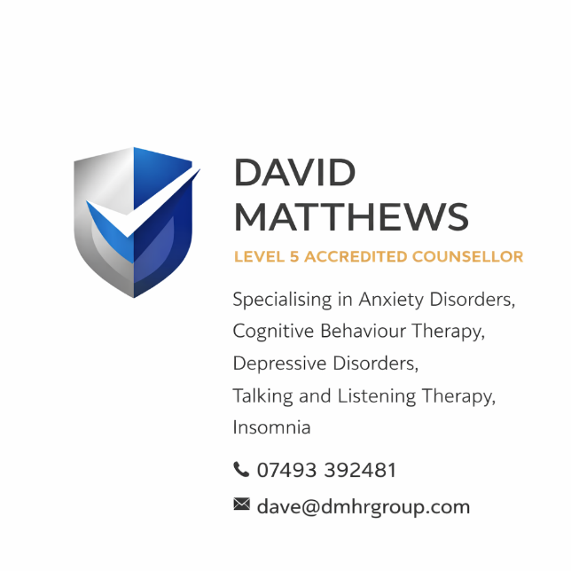

David Matthews Counselling Services

Complaints Policy & Procedure

1. Purpose
David Matthews Counselling Services is committed to providing a safe, professional, ethical, and confidential service at all times.
We recognise that, occasionally, a client may feel dissatisfied. This policy ensures that any concerns are handled:
- Promptly
- Fairly
- Respectfully
- Without judgement
Raising a complaint will not affect your right to ongoing support unless it is requested otherwise or deemed clinically appropriate.

2. Our Commitment to You
We are committed to:
- Treating all clients with dignity and respect
- Providing a safe, confidential, and non-judgemental environment
- Listening openly to concerns and taking them seriously
- Resolving complaints in a fair and transparent manner
- Using feedback to improve our services

3. What is a Complaint?
A complaint is:
Any expression of dissatisfaction regarding the counselling service, including conduct, communication, professional boundaries, or the quality of support provided.

4. How to Raise a Complaint
We encourage you to raise concerns at the earliest opportunity, either informally or formally.

Step 1 – Informal Resolution
Where possible, we encourage you to raise your concern directly with David Matthews.
Many issues can be resolved quickly through open discussion in a safe and supportive way.
You can do this:
- During a session
- By phone: 07493 392481
- By email: dave@dmhrgroup.com

Step 2 – Formal Complaint
If you feel the issue has not been resolved, you can make a formal complaint in writing.
Please include:
- Your full name and contact details
- A clear description of your concern
- Dates/times (where relevant)
- What outcome you are seeking
📧 Email: dave@dmhrgroup.com

5. What Happens Next
Once a formal complaint is received:
- Acknowledgement will be made within 3 working days
- A full review will be carried out
- You may be contacted for further information if required
- A written response will be provided within 10 working days
If more time is needed, you will be informed of the reason and given a revised timescale.

6. Possible Outcomes
Following investigation, outcomes may include:
- Clarification or explanation
- An apology where appropriate
- Agreement on actions to resolve the issue
- Changes to practice or procedures

7. Confidentiality
All complaints will be handled with strict confidentiality.
Information will only be shared where necessary to:
- Investigate the complaint
- Comply with legal or ethical obligations

8. If You Are Not Satisfied (External Complaints)
If you feel your complaint has not been resolved satisfactorily, you have the right to escalate it externally.

You may contact:

1. British Association for Counselling and Psychotherapy (BACP) (if registered)
Website: https://www.bacp.co.uk
They can review complaints relating to professional conduct and ethical practice.

2. National Counselling & Psychotherapy Society (NCPS) (if applicable)
Website: https://www.ncps.com
They provide an independent complaints process for registered counsellors.

3. Information Commissioner’s Office (ICO) (for data protection concerns)
Website: https://www.ico.org.uk
If your complaint relates to how your personal data has been handled.

4. Citizens Advice Bureau
Website: https://www.citizensadvice.org.uk
For independent advice on your rights and next steps.

5. NHS / GP (if referred service)
If your counselling was accessed via a referral, you may also raise concerns through your GP or referring organisation.

9. Safeguarding Concerns
If your complaint relates to safety, risk of harm, or safeguarding, this will be treated as a priority and may be escalated in line with safeguarding responsibilities.

10. Review of Policy
This policy is reviewed regularly to ensure it remains:
- Legally compliant
- Ethically sound
- Reflective of best practice

Contact Details
David Matthews Counselling Services
📞 07493 392481
📧 dave@dmhrgroup.com

